**PURBANCHAL UNIVERSITY**

FACULTY OF SCIENCE AND TECHNOLOGY

**COLLEGE OF BIOMEDICAL ENGINEERING AND APPLIED SCIENCES**

Lalitpur, Nepal



A Report On:

Submitted To:

Submitted By:

Roll No.:

Date of submission:

___________________________________

**COMPUTED TOMOGRAPHY (CT) SCAN**

**Introduction**

A CT scan, or computed tomography scan, is a medical imaging technique that uses X-ray technology to create detailed cross-sectional images of the inside of the body. The CT scan process involves taking a series of X-ray images from different angles around the body and using a computer to process this information and create detailed, three-dimensional images.

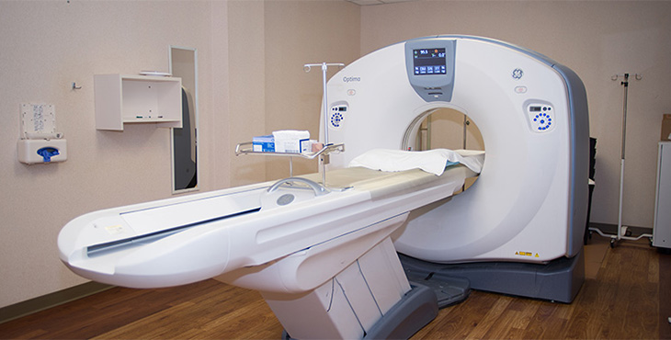

**Principle of CT scan**

* The basic principles of CT is that the internal structure of an object can be reconstructed from multiple projection.
* To carry out the reconstruction, the linear attenuation coefficient (µ) of the object is considered as base.

The working principle of CT scan involves 5 stages:

1. Scanning phase and data acquisition system
2. Pre-processing of raw data
3. Image reconstruction
4. Linear attenuation coefficient of each pixel is converted into CT number
5. Display and recording

**Need of CT scan**

* CT scans can detect bone and joint problems like bone fractures and tumors.
* CT scan can spot the conditions like cancer, heart disease, emphysema or liver masses or help doctor to see any changes.
* They show internal injury and bleeding.
* Doctors use CT scan to guide treatment plans and procedure such as biopsies, surgeries and radiation therapy.
* Doctors can compare CT scans to find out if certain treatments are working or not.

**Advantages of CT scan**

* Short study time and less confining environment than MRI
* Excellent in diagnosing diseases of the large vessel and the heart lining.
* Excellent in imaging abnormal coronary arteries from congenital causes.
* Provide high quality image
* CT scan is painless, non-invasive and accurate.

**Disadvantages of CT scan**

* Exposure to radiation.
* Contrast material may worsen kidney function in patient with kidney diseases.

**Generation of CT scan**

1. **First generation**

* It was rotate /translate pencil beam.
* Only 2 detectors were used. NaI is used as detector.
* This system used parallel ray geometry.
* It was designed specifically for evaluation of brain.
* In this, head was enclosed in water bath.

Advantage - reduce scatter radiation.

Disadvantage –NaI is hygroscopic, high scan time, poor spatial resolution

1. **Second generation**

* It was rotate /translate system with narrow beam geometry.
* 30 detectors were used and made up of NaI scintillator.
* Bowtie filter was firstly used in this generation.
* Scan time was reduced.

Advantage – short scan time, increase scanning speed

Disadvantage – NaI is hygroscopic, scatter radiation increased

1. **Third generation**

* It was rotate system with wide fan geometry.
* Up to 750 detectors were used.
* Detectors were aligned as an arc.
* Both xenon and scintillator detector were used.

Advantage – shorter scan time, elimination of complexity of translate – rotate motion, less patient dose.

Disadvantage – more scatter radiation, expensive than previous generation, ring artifact

1. **Fourth generation**

* It was rotate/stationery system with wide fan beam.
* Huge number of detectors were used.
* This generation was designed to overcome the ring artifacts.
* In this, detectors are aligned in a ring and completely surrounds the

Advantage – elimination of ring artifact, no complex circuit

Disadvantage – more scatter radiation, expensive than precious generation

1. **Fifth generation**

* It was stationery/stationery system.
* It was developed for cardiac imaging.
* No conventional x-ray tube is used.
* Large arc of tungsten surrounds the patient and lies opposite to detectors.
* It is also known as electron beam computed tomography (EBCT).

Advantages – short scan time, speed increased

Disadvantages – complex circuit, poor image quality, high equipment cost

1. **Sixth generation**

* It is the combination of third or fourth generation of CT with slip ring technology and helical motion.
* It is also known as helical /spiral CT scan
* Spiral CT is a technology in which source and detector travel along helical path relative to object.
* In this, x-ray tube rotates continuously and couch moves the patient through the plane of rotating beam.

Advantage – high speed, improved detection, no motion artifact, smooth movement of gantry and other component

Disadvantage – reduced resolution, more processing time

1. **Seventh generation**

* New technology
* Multidetector array
* Collimation spacing is wide and more x-ray produced are used in producing image data.
* Up to 8 rows of detectors
* Cone beam and multiple parallel rows of detector

Advantage – reduce scan time, increase z-resolution

Disadvantage – less scatter radiation, expensive

**Slip ring technology**

* In conventional CT scanning, there is paused between each gantry and rotation.
* But in helical CT, slip ring technology is used which allow continuous rotation of gantry without interruption.
* Slip ring are electrical conducting brushes and component of gantry transferring data or electrical energy from stationery part of gantry to rotating part of gantry for continuous rotation of gantry.

**Design of slip ring**

* **Cylinder type**
* In this design, a conductive ring remains/ lie parallel to the axis of rotation to form cylinder.
* **Disc type**
* In this, a conductive ring form concentric circles in plane of rotation.

**Types of slip ring**

On the basis of power supply, there are 3 types of slip ring:

1. **First slip ring**

* Provides high voltage power to x- ray tube
* In this system, AC provide power to high voltage generator which subsequently provides high voltage to slip ring. Then, high voltage transfer from slip ring to x ray tube. In this case, high voltage generator does not rotate with x-ray tube.

1. **Second slip ring**

* Provide low voltage to control system on rotating gantry.
* In this system, AC power and x-ray control signal are transmitted to slip ring by the means of low voltage brushes that glides on a contact groove on the stationary slip rings. Then, slip ring provide power to the high voltage to x –ray tube.
* Slip ring are made up of conduction material.

E.g.: silver and graphite

1. **Third slip ring**

* Transfer digital data from rotating detector.

**Significance of slip ring technology**

* Improved contrast
* Smooth movement of gantry and other components
* Allows transmission of power and electrical signals from stationery to rotating structure
* Greater accuracy for multiplanar and 3D images
* Scan time is reduced

**Component of CT scan**

1. Gantry
2. Detector
3. X-ray tube
4. Collimators
5. Patient Couch
6. Computer
7. Operating Console
8. **Gantry**

* It is the largest component of CT scan.
* It is ring shaped and diameter of gantry aperture ranges from 50-85 cm.
* It is mounted framework that surrounds the patient in vertical plane,

1. **Detector**

CT detector capture the radiation beam from the patient and convert it into electrical signal, which subsequently converted into binary coded information.

**Characteristics of detector**

* Efficiency
* Stability
* Response time
* Dynamic range
* After glow

**Types of detectors**

1. Gas Ionization Detector
2. Scintillation Crystal Detector

**Gas Ionization Detector**

* It uses Xenon gas and consist of series of individual gas chamber, usually separated by tungsten plate carefully positioned to act as electron collection plates with voltage applied across it.
* When x-ray beam interacts with xenon gas, it ionizes and provides electrical charge. The electrical charge is converted into electrical signal which is amplified and digitized.

**Scintillation crystal detector**

* These are solid state detector that consist of scintillation crystal couple to photodiode tube.
* When x ray beam falls on crystal, light signal are produces. These are then passed to PM tube that convert into electrical signal. Then, electrical signal are passed to TFT to produce digital image.

**Detector configuration**

1. Dual row detector

* It uses dual- row solid state detector array coupled with special x-ray tube based on double dynamic focus system.
* It results in simultaneous scan of 2 contiguous slices with excellent resolution.

1. Multi row detector

* The goal is to increase the volume coverage speed.
* They are solid state detector that can acquire 4 to 64 to 320 slices per 360degree rotation.
* it has 3 groups:

1. Multi-array detector:

* Referred to as fixed array detector
* Channel are equal in dimension.

1. Adaptive -array detector

* Channel are not equal in dimension

1. Hybrid detector

* Number of narrow detectors at center and wider detector at either side.
* Number of narrow and wide detector can vary.

1. **Collimators:**

* CT scanner uses one or two collimators which reduces patient dose and improve image quality.
* Multi- slice scanner uses only one collimator.

**Types of collimators:**

1. **Pre-patient collimator:**

* It is mounted on the tube housing or adjacent to it.
* It limits the area of patient that intercepts the useful beam and thereby determine patient dose.

1. **Post-patient collimator**

* It restricts the x-ray field viewed by detector array.
* It reduces scatter radiation incident on detector and when properly coupled with pre-patient collimator, helps to define slice thickness.
* It does not influence patient dose.

1. **X-ray tube**

* It is located in heart of gantry to provide radiation.
* In CT scan, it should supply monochromatic x-ray beam for accurate image reconstruction.
* Tube housing is made up of borosilicate and metal ceramic.
* Cathode is made up of tungsten and in CT, dual focal spots are present for high resolution.
* In CT, anode has larger diameter than in normal tubes and made up of tungsten and rhenium.

**Types of x-ray tube**

* Metal ceramics x-ray tuve
* Maximus rotalix ceramic x-ray tube
* Aquillion x-ray tube
* New straton tube

1. **Patient couch**

* It is made up of low atomic number material i.e. carbon fiber.
* It should be smoothly and accurately motor driven so that precise patient positioning is possible.

**MAGNETIC RESONANCE IMAGING (MRI)**

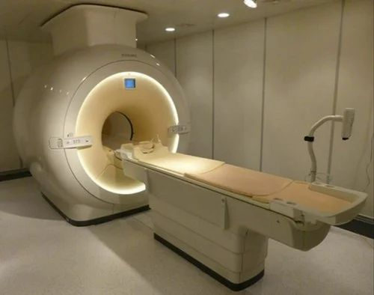Magnetic Resonance Imaging (MRI) is a medical imaging technique that utilizes strong magnetic fields and radio waves to generate detailed images of the internal structures of the body. Unlike X-rays or CT scans, MRI does not use ionizing radiation, making it a safer option for both patients and healthcare professionals.

**Principles of MRI:**

MRI relies on the principles of nuclear magnetic resonance (NMR). When exposed to a strong magnetic field, certain atomic nuclei, such as those of hydrogen, align themselves. Radiofrequency pulses are then applied, causing these nuclei to emit signals that are detected by the MRI machine. By analyzing these signals, a computer creates detailed, cross-sectional images of the body.

**Components of MRI:**

**1. Gantry**

* **Magnets and its types**
* **Patient couch**

**2. Coils**

* **RF coils**
* **Gradient coils**
* **shim coils**

**3. Operating console**

**4. Computer**

1. **Gantry**

* it is the largest component of MRI. It is composed of magnets.

MRI magnets:

* It is the heart of MRI system.
* The requirement for magnets are:
* To produce magnetic field of proper strength
* To produce a homogenous magnetic field
* To allow access for patients

**Types of magnets**

* **Permanent magnet**
* Consists of a material which has been magnetized such that it won’t loose its magnetic field
* Commonly made of an alloy ALNICO and Rare earth materials
* No current is required to maintain magnetic field
* Produces low magnetic field strength of 0.3T
* **Resistive magnet**
* Consists of huge copper or aluminum coils
* They produce a lot of heat so requires water cooling
* It can be switched on and off
* Produces magnetic strength of 0.5T
* **Superconducting magnet**
* Special alloys of Titanium and Niobium in a copper matrix when super cooled to a temperature of 4K (-2690C) becomes super conductor
* Produces high magnetic strength of 3T
* The coolant or the cryogen used is liquid helium

2. **Coils**

1. **Shim coils**

* shim coils eliminate any inhomogeneity with in the magnetic field.
* Inhomogeneity may arise from magnet or surrounding in which magnet is placed.
* shim coils super impose over the main magnetic and correct field differences
* shim coils work with direct current (DC).

1. **Gradient coils**

* They provide gradient magnetic field.
* There are 3 set of gradient coils:
* X-gradient → Frequency encoding
* y-gradient → phase se encoding
* z-gradient → slice selection
* All coils are connected to amplifier which control rise time and maximum value of gradient.
* These coils produce large sound so they can be switched off rapidly.

1. **RF coils**

* These coils generate magnetic field perpendicular to main magnetic field.
* The signal produced by resonance/relaxation needs to be detected to enable image production.
* These coils transmit and receive RF signals from patient.
* The requirement of RF coils:
* To surround subject to be sampled.
* should be closer to imaging parts

**Types of RF coils:**

* Volume coil
* Head coil, knee coil, breast coil
* Surface coil
* Shoulder coil, flex coil, neck coil

3. **Operating console**

* It is placed where operator can operate or control the MRI machine
* It also consists of scanning parameters, image manipulation techniques.

4. **Computer**

* The MRI image is displayed and stored in the computer.

**Design of MRI room**

* MRI room liked a is constructed by using copper sheet walled basket called Faraday's Cage.
* The walls of MRI room are constructed in layer and perform several independent functions:
* magnetic shielding → To confine fringe field
* acoustic shielding →To restrict noise transmission to control room and beyond
* Radio-frequency shielding →To prevent electromagnetic noise from entering or leaving the room.

**Possible risk in MRI**

1. Bio-effects
2. Vertigo
3. Nausea
4. Phosphenes
5. Metallic taste
6. Magnetic forces
7. Missile effect
8. Torque
9. Acoustic noise
10. Claustrophobia
11. Quenching

**Safety precaution in MRI**

1. Make sure that before entering the MRI room. there are no magnetic objects before entering the MRI room
2. Be careful about metal trays placed in blind spots, such as under drapes.
3. Provide patient clear instructions not to grasp the top board during an MRI scan.
4. Warning signs must be clear in MR area,
5. Do not use unapproved accessories or software
6. Keep MR door closed all the time.
7. Create Emergency plan for evacuation

**Advantages of MRI:**

* **Non-invasiveness**: MRI is a non-invasive imaging technique that does not use ionizing radiation, making it safer than some other imaging modalities like X-rays or CT scans.
* **Soft Tissue Contrast:** MRI excels in providing excellent contrast between different soft tissues, such as organs, muscles, and nerves. This makes it particularly useful for imaging the brain, spinal cord, and joints.
* **Multiplanar Imaging:** MRI can produce images in multiple planes (sagittal, coronal, and axial), allowing for a comprehensive view of the anatomy and aiding in the diagnosis of various conditions.
* **Functional Imaging:** Functional MRI (fMRI) can be used to assess brain activity by measuring blood flow, helping in the study of neurological conditions and brain function.
* **No Radiation Exposure:** Unlike X-rays and CT scans, MRI does not expose patients to ionizing radiation, making it a safer option for repeated imaging studies, especially for certain populations like pregnant women and children.
* **High Resolution:** MRI has the capability to provide high-resolution images, allowing for detailed examination of small structures and early detection of abnormalities.

**Disadvantages of MRI:**

* **Cost:** MRI machines are expensive to purchase, install, and maintain. This can result in higher overall healthcare costs, affecting accessibility for some patients.
* **Limited Availability:** In some regions, access to MRI machines may be limited due to their high cost and the need for specialized facilities and trained personnel.
* **Patient Limitations:** Certain patients, such as those with claustrophobia or implanted metallic devices, may find it challenging to undergo an MRI. Open MRI machines and the development of more MRI-compatible implants have helped address some of these limitations.
* **Longer Exam Times:** MRI scans can take longer to acquire compared to other imaging modalities, which might be a challenge for patients who have difficulty remaining still.
* **Not Suitable for Emergency Cases:** MRI may not be the best choice for emergency cases or patients with certain conditions that require rapid imaging, as the process can be time-consuming.
* **Contrast Agent Use:** In some cases, a contrast agent (gadolinium) may be used to enhance the visibility of certain tissues. While generally safe, there have been concerns about the potential accumulation of gadolinium in the body, particularly in patients with impaired kidney function.

**ULTRASONOGRAPHY**

**Introduction**

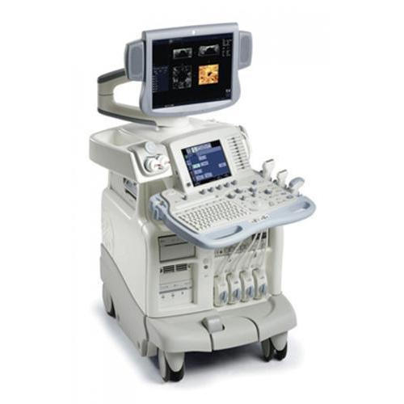Ultrasound is a sound having frequency greater than 20kHz which cannot be heard by human ear.

**Characteristics of US**

1. Need medium for propagation
2. Travels in straight line
3. Behave like electromagnetic radiation
4. Propagation of ultrasound occurs in manner of compression and rarefaction

**Interaction of US with tissue**

When US wave penetrate the skin, it interacts with various body tissue. There are 3 interactions in general.

1. Reflection
2. Attenuation (Absorption and scattering)
3. Refraction

**Ultrasonography**

It is an imaging method that uses sound waves to produce images of structure within body. The images can provide valuable information for diagnosis and directing treatment of variety of disease and condition.

**Principle of US**

1. Us imaging is based on principle of piezo-electric effect.
2. piezo-electric material has dipoles which contain the positive or negative charges and net charge is zero.
3. when an electric voltage is applied across crystal, dipole orientation changes resulting in variation of crystal thickness and crystal undergoes compression & expansion and these changes/vibration produces
4. sound waves that travel outward. similarly, when mechanical pressure is applied to crystal, molecular dipole changes their orientation altering the electric field and produce voltage signal

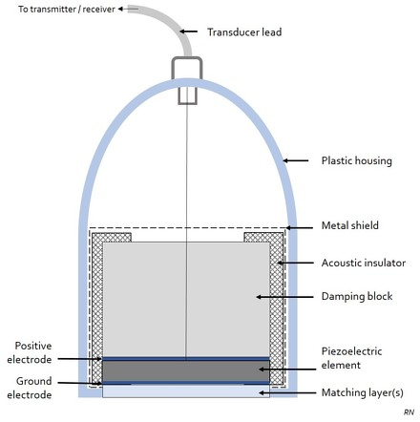**Ultrasound transducer**

The major components of ultrasound transducer are

1. Matching layer
2. Piezo-electric crystal
3. Backing block
4. Acoustic absorber
5. Transducer Housing
6. Co-axial Cable

**Piezo-electric crystal**

* These are active and most important element of transducer.
* The electrical energy is provided to the sound ware by the vibrating piezo element.
* Piezo-electric crystal is made up of quartz but now Ceramic materials are used to produce ultrasound.
* Ceramic material used is Barium Titanate (artificial element) which is replaced by lead zirconate Titanate (PZT) and also PVDF.
* To make ceramic piezoelectric crystal, material need to provide heat above its curie temperature under high voltage.
* Frequency of us depend on the thickness of crystal. Generally, the thickness of crystal is about 0.5mm.

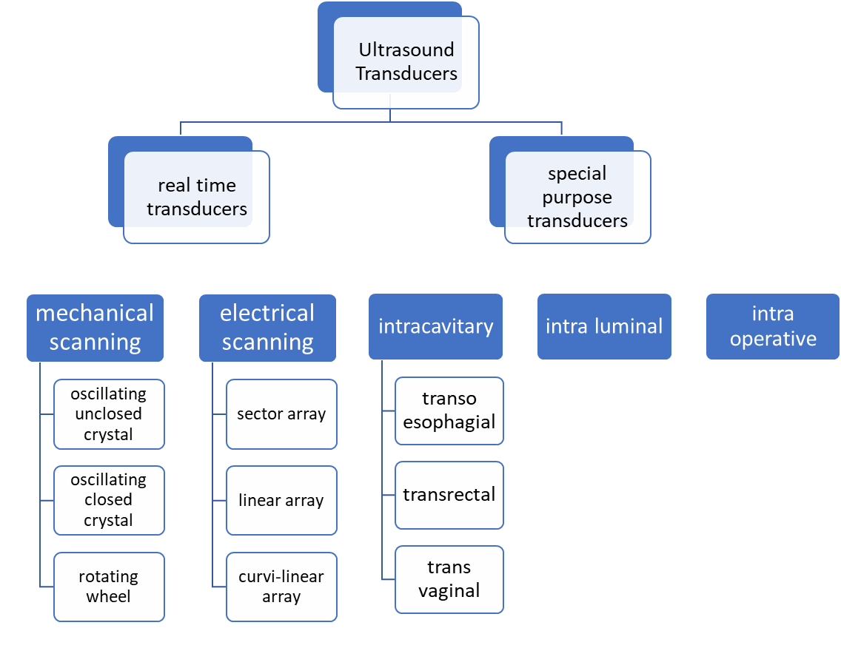Types of transducers

**USG image display**

* ultrasound imaging can be done in 3-mode:

1. Amplitude mode (A-mode)
2. Brightness mode (B-mode)
3. Motion mode (M-mode)

**Doppler effect**

* It is change in frequency of sound due to relative motion of source and rectifier
* It is useful in us imaging to get information about blood flow in arteries and vein.

**COMPUTED RADIOGRAPHY**

Computed radiography is the digital replacement of conventional x-ray film radiography. It is a process of capturing radiographic data from a conventional x-ray machine and processing the data digitally to produce high quality radiographic images.

**Components of CR**

1. Image acquisition system/imaging plate (IP)
2. Imaging plate reader
3. Image display system
4. Image storage system
5. **Imaging plate**

* In CR, image is captured in thin sheet of plastic know as imaging plate
* Imaging film is similar to conventional screen film cassette
* Imaging plate is made up of several layers
  1. Protective layer
* It is thin, tough, clear plastic that protects the phosphor/active layer of imaging plate
  1. Phosphor / active layer
* This is a layer of photostimulable phosphor that traps electron during exposure.
* This layer has the property of storing radiation energy for a while
* It is usually made up of phosphors from barium fluorohalide family.
* Europium is doped in barium florohalide crystals which acts like an activator for PSL property and create defects in crystal for trapping electrons.
  1. Reflective layer
* This layer reflects the light to the reader.
  1. Conductive layer
* This layer absorbs light as well as any electrical charge.
  1. Supportive layer
* This layer is made up of polyester and gives some strength to imaging sheet / plate.

1. **Imaging plate reader**

* The reader is the most critical part of the CR imaging system
* After the radiation exposure CR cassette is inserted into the reader where the imaging plate is removed and fitted into drive mechanism
* The drive mechanism moves the plate with constant velocity along the y-axis. This is usually done with slow motion and it is also called slow scan mode
* A rotating and multifaced mirror reflects the red light from a laser light source (He-Ne laser, 633nm)
* This light is deflected back and forth across the phosphor plate in the horizontal, x direction which releases visible, blue green light of 390nm. This is done by fast scan mode.
* Both fast and slow scan mode are controlled by CR computers
* The blue green light is collected by photomultiplier tube (PMT) through the fiber optic light guide
* The PMT amplifies the signal and keeps the output electronic signal which is feed into the computer for further processing.

CR reader takes about 110 sec to process each cassette.

1. **Image display system**

* From the reader, electronic signal is obtained and fed into analogue to digital converter (ADC).
* ADC converts electronic signal into digital signal, which will be displayed on computer and further processing of image can be done.

1. **Image storage system**

* After display of image, image can be printed or stored.
* The image is stored in the computer and from this storage system, we can retrive the image whenever we want.

**Principles of CR**

Computed radiography is based on Photo-stimulable Luminescence (PSL) principle.

* CR employs a phosphor which work on PSL principle
* When the phosphor is exposed to radiation, it absorbs the radiation and store the energy.
* Later, when it is stimulated by different light sources: it gives Luminescence.
* The amount of luminescence is proportional to the radiation exposure.

i.e Luminescence α radiation exposure

Radiation



Phosphor will absorb it and store its energy

Phosphor

Light source

Phosphor will emit visible light (luminescence)



radiation

Phosphor



Luminescence

Fig: working principle of CR

**Advantages of CR**

* The sample plate can be used again and again.
* It does not require a dark room and developing chemicals.
* The produced image is digital and can be stored and manipulated electronically
* These images have greater dynamic range, wider exposure latitude and reduced patient exposure.

**Disadvantages of CR**

* CR requires the cassette be removed from the x-ray machine and then placed into a reader.
* The PSPs used in CR require longer readout and processing time.
* When single plate readers are used, overexposure entail additional delay as the old signals are not completely erased very quickly.
* PSP plates used in CR have lower efficiency of detection compared to DR detectors. So, higher radiation dose is needed to obtain adequate image resolution.

Image manipulation techniques in CR

1. Image rendering
2. Create a shadow
3. Proportion
4. Texture application
5. Stock image selection
6. Color combination
7. Emphasis on the smallest details
8. Image combination
9. Enhancing a stock photo

**Digital Radiography (DR)**

* It is a technique in which conventional silver halide film or PSP screen like radiation receptor are replaced by photo-electronic receptor which is connected directly to computer.

**Principle of DR**

* X-ray signals can be digitized by using detector.
* Firstly, x-ray falls on detector which converts x-ray signed into electronic signal.
* These signal falls on Thin Film Transistor (TFT) or Charge Couple Device (CCD) where they are converted into digital signals.

X-ray



Fig: working principle of DR

Digital signal

Electrical signal

TFT/CCD

Detector

**Components of DR**

1. X-ray equipment
2. Detector
3. Thin film transistor (TFT)
4. Charge couple device (CCD)
5. Computer system

**X-ray equipment**

* An x-ray machine is same as conventional x-ray machine is used.
* High power generators used.

**Detectors**

* Major function of detector is conversion of x-ray signal into electronic signal.
* Types of detectors:
* Indirect digital detector (Cesium Iodide, Gadolinium oxysulfide)
* Direct Digital Detector (Selenium)

**Thin film transistor (TFT)**

* It can be used with both direct or indirect digital detector.
* It is also known as Flat Panel Detector (FPD)
* TFT has three connections:
  1. **Source:** capacitor
  2. **Gate:** connected to horizontal lines (rows)
  3. **Drain:** connected to vertical or read out line (column)

**Charged coupled device (CCD)**

Fig: Thin Film Transistor diagram

* It forms images from visible light.
* It is usually used with Intensifying screen and image intensifier tube.
* CCD is an integrated circuit made up of metal oxide crystalline silicon capacitor.

**Computer**

* In computer system, digital image is manipulated by different means like contrast enhancement, brightness control etc.
* From this computer system, the digital image will go to either in printer system or in storage system.

**Advantages of DR**

* Increased dynamic range
* Linear response of image
* Easy to archive since images are in digital format
* Easy image storage
* Quick image sharing
* Availability of post-processing functions

**Disadvantages of DR**

* Poor spatial resolution
* Artifacts due to imaging plate, image processing algorithm etc.
* Increased sensitivity to scattered radiation
* More expensive
* Thickness and rigidity of digital detectors
* Hardware and software maintenance

**MAMMOGRAPHY**

**Introduction**

The x-ray of other part of body can be done using normal x-ray but the x-ray of breast cannot be performed using normal x-ray. For x-ray of breast, a different x-ray machine is designed and the process is known as mammography.

* Mammography machine takes less x-ray than usual x-ray machine.
* Mammography is a medical imaging technique which is especially designed for breast in detection of breast condition and disease (Breast cancer).
* It is used for detecting a tumor is benign or malignant, palpable lump, cyst, calcification nipple discharge.

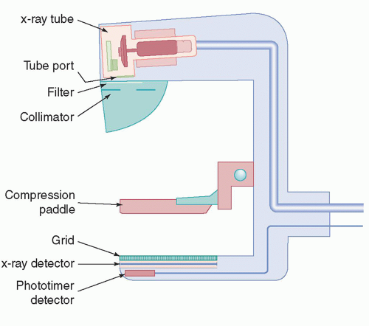

**Components of x-ray**

1. Generator
2. Mammography x-ray tube
3. Target material
4. Focal spot
5. Filter
6. Collimator
7. Compression paddle
8. Grid
9. Automatic exposure control (AEC)

* X-ray generator is required for delivery, modulating and regulating electrical energy required by X-ray tube cathode heating current tube current anode drive and AEC.
* Mammography X-ray tube is vacuum tube contains anode and cathode. Anode is made up of Molybdenum, and rhodium.
* In mammography, focal spat is smaller than that used in other radiology. It is about 0.3mm for Standard view images and 0.1mm for magnification.
* Depending on thickness and density of breast auxiliary, filters are placed in radiation path to optimize the radiation quality.
* Compression paddle can be adjusted manually or via a foot switch and breast thickness and pressure are shown on display.
* Special soft grids have been developed for use in mammography that reduce relative proportion of scattered radiation to total radiation from approximately 45% to 5%.
* Mammography system have AEC to prevent incorrect exposure.

**Advantages**

* Reduce risk of dying from breast cancer
* Reduce risk of having to undergo chemotherapy
* Allows women to know the condition of their breast

**Disadvantages**

* Periods of waiting and anxiety when additional examinations are required
* possible over diagnosis

**Limitation**

* All the breast cancers will not be detected and diagnose.